Project Planning Phase
Project Planning Document (Product Backlog, Sprint Planning, Stories, Story points)

Date | 15 February 2026
Team ID | LTVIP2026TMIDS79115
Project Name | Cafeteria Menu Display
Maximum Marks | 5 Marks

Product Backlog, Sprint Schedule, and Estimation (4 Marks)
Sprint | Functional Requirement (Epic) | User Story Number | User Story / Task | Story Points | Priority | Team Members
Sprint-1 | Project Setup | USN-1 | Set up development environment with Flask and MySQL | 2 | High | Member 1
Sprint-1 | Project Setup | USN-2 | Create project folder structure and initialize Git | 1 | High | Member 2
Sprint-1 | Database Design | USN-3 | Create Users table in MySQL database | 2 | High | Member 3
Sprint-1 | Database Design | USN-4 | Create Categories table in MySQL database | 2 | High | Member 4
Sprint-1 | Database Design | USN-5 | Create Menu Items table in MySQL database | 3 | High | Member 5
Sprint-2 | Backend Development | USN-6 | Create Flask app with basic routes and config | 2 | High | Member 1
Sprint-2 | Authentication | USN-7 | Implement admin login with session management | 3 | High | Member 2
Sprint-2 | API Development | USN-8 | Build API endpoints to fetch menu items | 2 | High | Member 3
Sprint-2 | API Development | USN-9 | Build API endpoints to add new menu items | 3 | High | Member 4
Sprint-2 | API Development | USN-10 | Build API endpoints to edit and delete items | 3 | Medium | Member 5
Sprint-2 | Admin UI | USN-11 | Design admin panel HTML forms | 2 | Medium | Member 1
Sprint-3 | Frontend Display | USN-12 | Design customer display interface with HTML/CSS | 3 | High | Member 2
Sprint-3 | Frontend Logic | USN-13 | Implement JavaScript to fetch and render menu | 2 | High | Member 3
Sprint-3 | Frontend Logic | USN-14 | Add category-based filtering functionality | 2 | Medium | Member 4
Sprint-3 | Automation | USN-15 | Implement auto-refresh every 5 minutes | 2 | Medium | Member 5
Sprint-3 | UI Enhancement | USN-16 | Add dietary icons (Veg, Vegan, Gluten-Free) | 3 | Low | Member 1
Sprint-3 | UI Enhancement | USN-17 | Implement "Today's Special" highlight feature | 2 | Low | Member 2
Sprint-3 | UI Enhancement | USN-18 | Add "Out of Stock" grayed-out display logic | 2 | Medium | Member 3

Project Tracker, Velocity & Burndown Chart: (4 Marks)
Sprint | Total Story Points | Duration | Sprint Start Date | Sprint End Date (Planned) | Story Points  Completed (as on  Planned End Date) | Sprint Release Date (Actual)
Sprint-1 | 10 | 5 Days | 5 Feb 2026 | 9 Feb 2026 | 10 | 9 Feb 2026
Sprint-2 | 15 | 5 Days | 10 Feb 2026 | 14 Feb 2026 | 15 | 14 Feb 2026
Sprint-3 | 16 | 5 Days | 15 Feb 2026 | 19 Feb 2026 | 16 | 19 Feb 2026

Velocity Calculation
Total Story Points = 10 + 15 + 16 = 41
Number of Sprints = 3
Velocity = 41/ 3 = 13.67 Story Points per Sprint

Burndown Chart
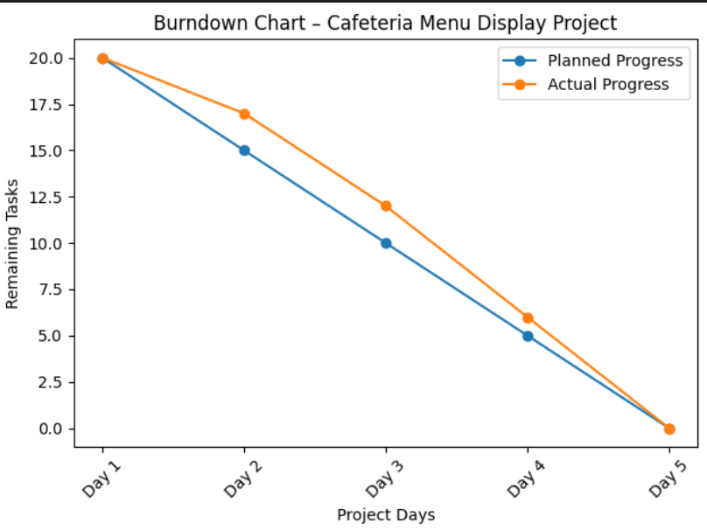
The burndown chart represents the progress of Sprint-3 by showing the remaining story points over the sprint duration. The ideal line indicates expected progress, while the actual line shows real completion. All planned story points were completed by the end of the sprint, indicating successful sprint execution.

